Task 2

Lab 2: Two Ray Ground Reflection Model

NAME: ABDELRAHMAN MATARAWY SAYED

# SECTION: 5

* **Objectives:**
  + Observing the effect of ground reflection on the wireless channel.
  + Implementing the two ray ground reflection model in MATLAB.
* **Summary:**
  + Friis propagation model considers the line-of-sight (LOS) path between the transmitter and the receiver. The expression for the received power becomes complicated if the effect of reflections from the earth surface has to be incorporated in the modeling. In addition to the line-of-sight path, a single reflected path is added in the two-ray ground reflection model.
* **The distances traveled by the LOS ray** **and the reflected ray are given by:**

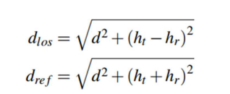

* **phase difference (f) between the LOS ray and reflected ray:**

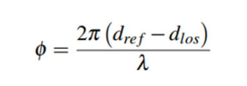

* **the power of the received signal can be expressed as:**

* **Task (2):**
  + a WiFi (IEEE 802.11n standard) transmission-reception system operating at f = 2.4 GHz band with 1 mW output power from the transmitter. The gain of the transmitter antenna is 3 dBi and the receiving antenna is isotropic.

1. 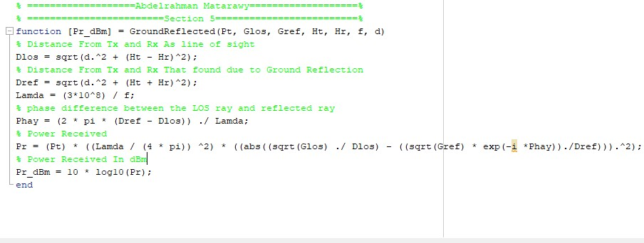Implement a MATLAB function that calculates the received power according to according to the 2-ray ground reflection Model.
2. MATLAB function Using the approximation:

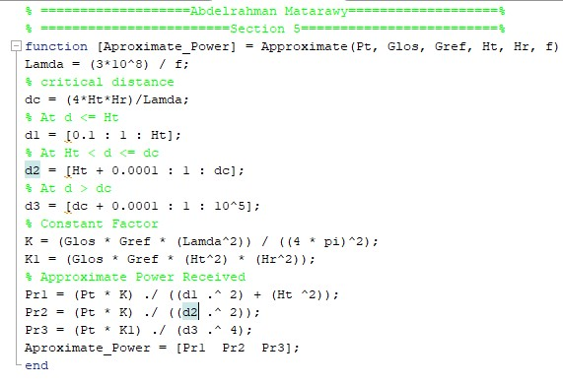

1. Main Code:

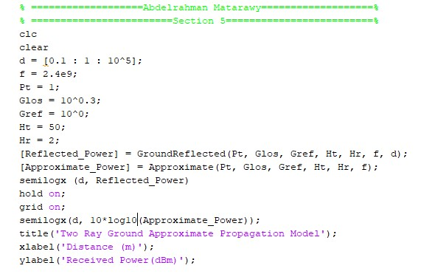

1. Plot the received power versus distance using the two functions:

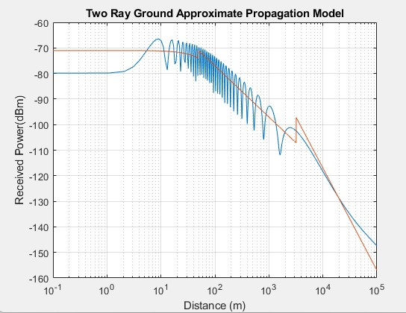

“Exact Blue One and Approximate is Red One”